Chicken Coop Monitor  
Installation and User Manual

July 24, 2021

Contents

Installation Manual 1

Included Installation Components 1

Installation Notes: 2

Raspberry Pi Zero 3

Board Layout 3

Board Circuit Diagram 5

Software Installation 5

Raspberry Pi Pico 9

Board Layout 9

Board Circuit Diagram 12

Software Installation 13

Relay Control Box 15

User Manual 17

Accessing the Login Screen 17

User Login 17

User Account Recovery 18

Register a New User Account 18

Signing Out 19

Editing A User Profile 20

Accessing Sensor Data 21

Interpreting Sensor Data 22

Accessing The Coop Camera and Camera LED 23

Accessing the Doorkeeper Override 24

Alert LED’s 24

# Installation Manual

## Included Installation Components

* 1 x Controller Box – comes preassembled with the following components:
  + 1 x 8” USB OTG Cable (Micro-USB to Micro-USB)
  + 1 x mini-CSI Cable
  + 1 x Raspberry Pi Zero W, with control board
  + 1 x Camera Module with Foam Shroud
  + 1 x 16Gb Micro SD Card
  + 1 x Raspberry Pi Pico Microcontroller, with control board
  + 1 x Reset Cable
  + 3 x modular resistors:
    - 2 x 1,000 Ohm (brown-black-red-gold)
    - 1 x 220 Ohm (red-red-brown-gold)
* 1 x 10’ Micro-USB Cable
* 1 x 3’ USB Power Cable
* 2 x USB Power Supply
* 1 x Relay Box – comes preassembled with the following components:
  + 1 x 4-relay board
* 2 x Temperature Sensors
* 3 x Reed Switches with Magnets
* 2 x Alert LEDs
* 1 x Camera LED
* 1 x Doorkeeper Control Cable
* 1 x Relay Control Cable

## Installation Notes:

During installation, you may wish to record some system settings. This page has been provided for this purpose.

|  |  |
| --- | --- |
| Pi Zero System Username: |  |
| Pi Zero System Password: |  |
| Pi Zero System IP Address: |  |
|  |  |
|  |  |
|  |  |
|  |  |
|  |  |

Additional Notes:

## Raspberry Pi Zero

### Board Layout

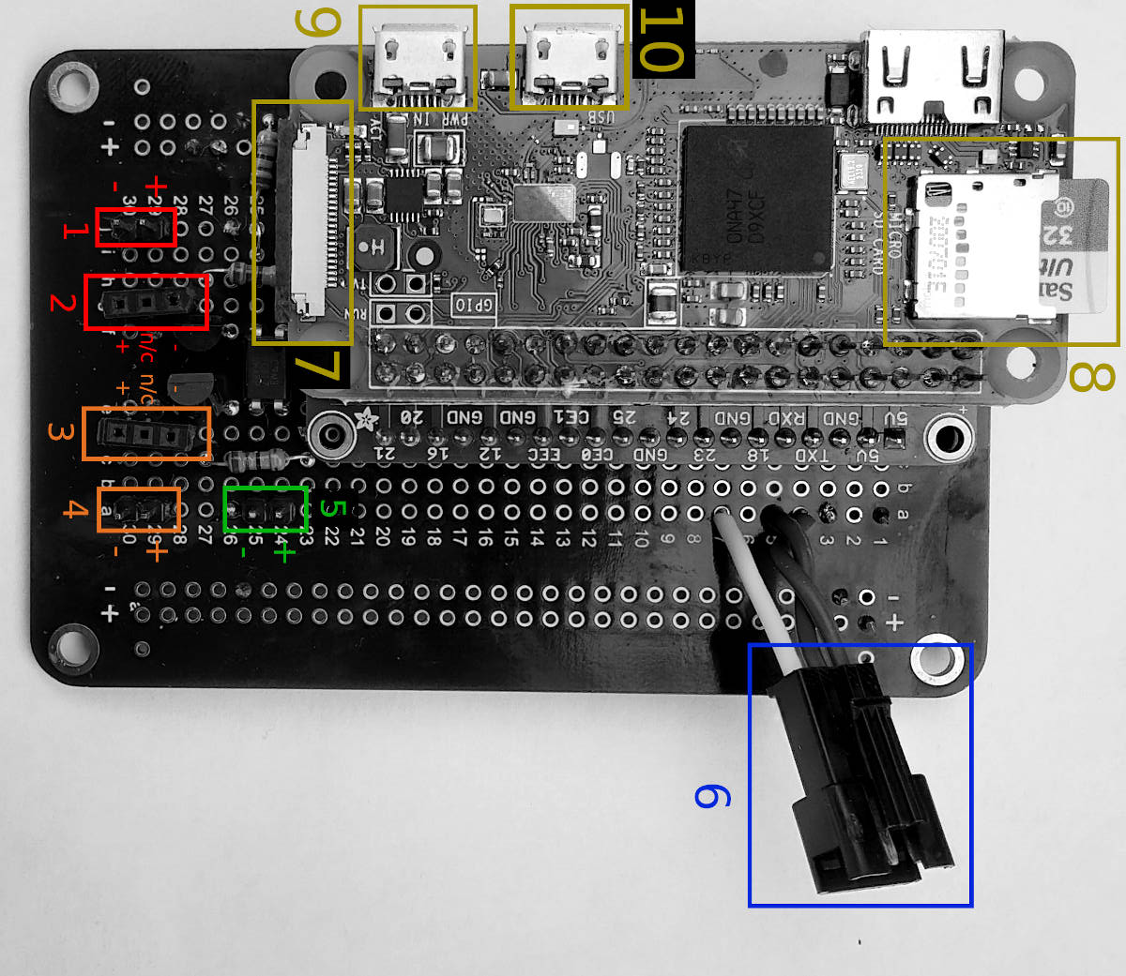

|  |  |  |
| --- | --- | --- |
| **#** | **Connector** | **Description** |
| 1 | 2-pin Male | 5.0v Camera LED Connector  +: Copper coloured cable  -: Silver coloured cable |
| 2 | 3-pin Female | Modular Resistor Connector - Camera LED |
| 3 | 3-pin Female | Modular Resistor Connector - Alert LED |
| 4 | 2-pin Male | 3.3v Alert LED Connector  +: Copper coloured cable  -: Silver coloured cable |
| 5 | 2-pin Male | Pi Pico Reset Connector  +: Copper coloured cable  -: Silver coloured cable |
| 6 | 3-pin Male JST Connector | UART Connection:  Red Wire - TX  Green Wire - RX  White Wire - Ground |
| 7 | CSI Connector | Raspberry Pi Camera Connector |
| 8 | Micro SD Card | Raspberry Pi Zero Micro SD Card |
| 9 | Micro-USB | Power Connector |
| 10 | Micro-USB | USB Connector |

#### Modular Resistor Connector

The Modular Resistor Connector accepts a current-limiting resistor to prevent an LED from burning out. The value of this resistor needs to be sized according to the LED being used on the related LED connector. A resistor of higher-than-required resistance may be used to dim the LED if desired.

#### 5.0v Camera LED Connector

Plug the Camera LED cable into this connector. LED’s are polarity-sensitive, so it is important to orient the plug correctly. This LED should be paired with a minimum 220 Ohm Modular Resistor.

#### 3.3v Alert LED Connector

Plug the Alert LED cable into this connector. LED’s are polarity-sensitive, so it is important to orient the plug correctly. This LED should be paired with a minimum 1k Ohm Modular Resistor.

#### Pi Pico Reset Connector

Plug the 2-pin female end of the Reset Cable into this connector. This cable is polarity-sensitive, so it is important to orient the plug correctly. The other end of this cable should be plugged into the reset connector of the Raspberry Pi Pico.

#### UART Connection

Plug this connector into the female JST connector on the Raspberry Pi Pico board. The cables are already set up to correctly cross RX and TX lines for UART communication.

#### Raspberry Pi Camera Connector

Plug the small end of the Raspberry Pi Camera Cable into this connector. The black side of the cable end should be facing up (away from the board) with the copper leads facing down (towards the board).

#### Raspberry Pi Zero Micro SD Card

Insert a Micro SD Card that has been flashed with Raspberry Pi OS (see Software Installation).

#### Power Connector

Insert the Micro-USB end of the supplied 10’ Micro-USB power cable into this connector. The other end of this cable should be plugged into the provided USB power supply.

#### USB Connector

Insert the ‘host’ end of the supplied 8” Micro-USB OTG cable into this connector. The other end of this cable should be plugged into the Micro-USB port of the Raspberry Pi Pico.

**IMPORTANT NOTE: All sensors, cables and control boxes should be installed in a dry location.**

### Board Circuit Diagram

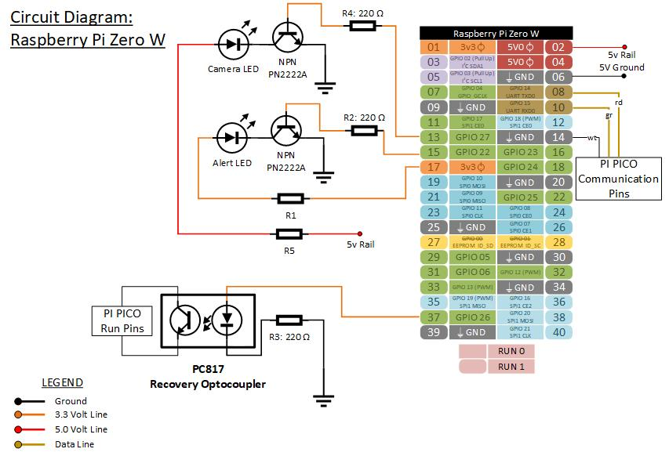

### **Software** Installation

The Raspberry Pi Zero software for your system comes pre-installed on the supplied Micro SD Card. However, if you need to replace the software or the SD card, the following procedure can be used to build the system. This procedure can be followed by advanced users. Novice users should seek professional assistance.

#### 1) Install Raspberry Pi OS:

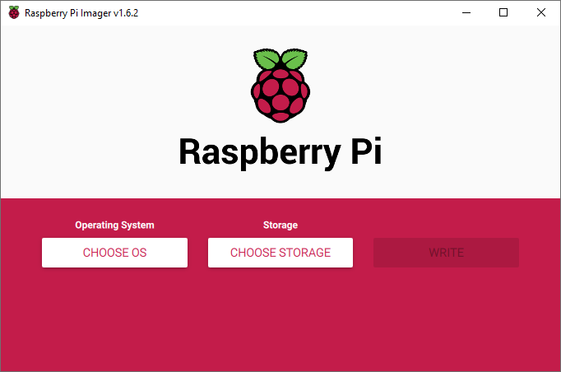

1. Insert the Micro SD card into your computer. A USB adapter may be required if your system does not have a built-in Micro SD card reader.
2. Download and install the Raspberry Pi Imager from <https://www.raspberrypi.org/software/>.
3. Open Raspberry Pi Imager
4. For Choose OS, select “Raspberry Pi OS Lite (32-bit)”.
5. For Choose Storage, select your Micro SD card.
6. Click ‘Write’.

#### 2) Boot the Raspberry Pi Zero

1. Connect a keyboard and monitor to the Raspberry Pi Zero
2. Connect the power cable to boot the system.
3. Log into the system using the default Login credentials:  
    Username: pi  
    Password: raspberry

#### 3) System Setup

It is recommended that you change the default password with the ‘passwd’ command. You may wish to record the new password on the Installation Notes page for future reference.

It is also recommended that a static IP address be set for the Raspberry Pi Zero so that it does not change unexpectedly. This makes the device easier to access on the network by users. You may wish to record the new IP address on the Installation Notes page for future reference.

1. Enter the following command: **nano /etc/dhcpcd.conf**
2. Scroll down to the end of the file and copy the following lines into the file. The IP addresses in these lines should be edited to suit your own home network.

**interface wlan0**

**static ip_address=192.168.1.200/24**

**static routers=192.168.1.254**

**static domain_name_servers=192.168.1.254 8.8.8.8**

1. Use the following keyboard combination to save the changes: ctrl+s
2. Exist the editor: ctrl+x
3. Use the raspi-config utility to edit the wireless LAN settings:
   1. Enter the following command: sudo raspi-config
   2. Go into System Options
   3. Go into Wireless Lan
   4. Follow the prompts to enter the WiFi network name and passphrase.
   5. Exit the raspi-config utility
4. It is recommended, but not required, that SSH be activated for remote administration:
   1. Enter the following command: sudo raspi-config
   2. Go into Interface Options
   3. Go into SSH
   4. Follow the prompts to activate SSH.
   5. Exit the raspi-config utility

#### 4) Download Chicken Coop Monitor Software

Run the following commands to download the chicken coop software:

1. sudo apt install git -y
2. cd $HOME
3. git clone --recurse-submodules <https://github.com/infonick/ChickenCoopMonitor.git>

#### 5) Run the Installation Script

|  |
| --- |
| IMPORTANT NOTES:   * The script makes extensive use of the 'sudo' command in order to complete the installation and many changes will be made to your system. * The script will perform a system update on the Raspberry Pi Zero and install any required dependencies. This may take some time to complete. * The script will set up UART communication with PL011 for best communication reliability. However, enabling the PL011 UART requires disabling Bluetooth. * Your crontab file will be amended with two additional startup processes. The original crontab file will be backed up in the “$HOME/ChickenCoopMonitor/Zero\ Code/” folder in case you need to restore it. |

Run the following commands to install the chicken coop software. If this is the first time installing the software on a new system, you should answer ‘y’ or ‘yes’ to all prompts.

1. cd $HOME/ChickenCoopMonitor/Zero\ Code/
2. chmod +x ZeroSetupScript.bash
3. ./ZeroSetupScript.bash
4. When the script is complete, you should reboot the system for all changes to take effect.

The Chicken Coop Monitor system should now be installed. You can confirm the installation by following the instructions in the User Manual to access the interface. Please note that in order for the interface to work, the Raspberry Pi Pico must be installed and connected to the Raspberry Pi Zero. In order for the camera to work, the camera must have been connected to the Raspberry Pi Zero.

## Raspberry Pi Pico

### Board Layout

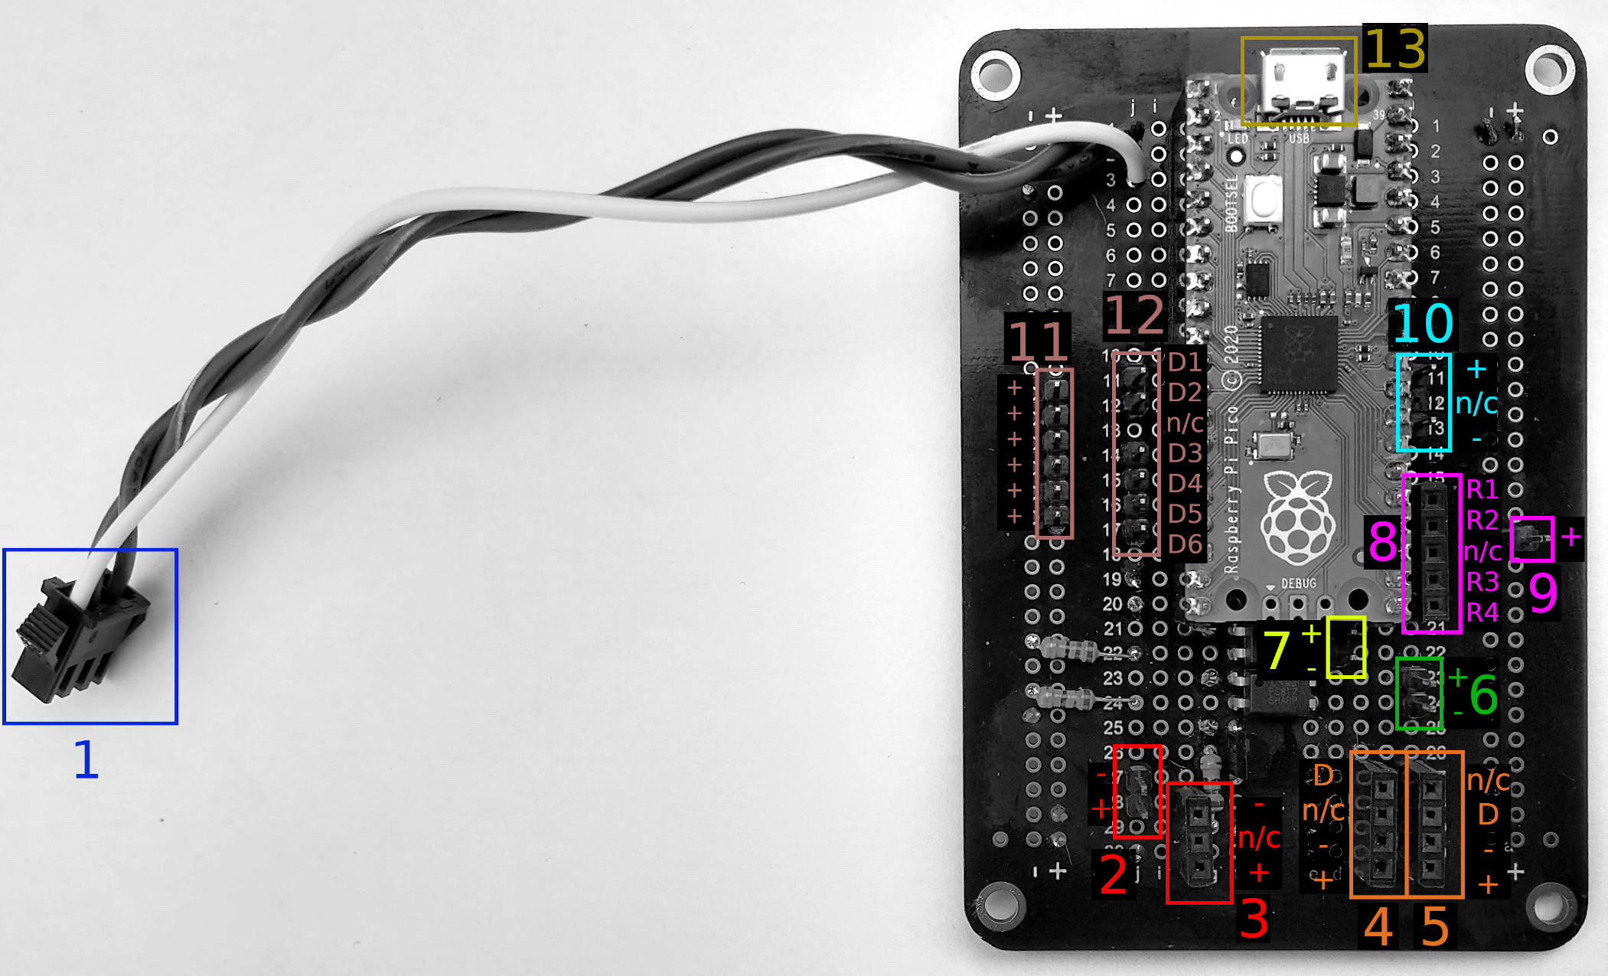

|  |  |  |
| --- | --- | --- |
| **#** | **Connector** | **Description** |
| 1 | 3-pin Female JST Connector | UART Connection:  Red Wire - RX  Green Wire - TX  White Wire - Ground |
| 2 | 2-pin Male | 3.3v Alert LED Connector  +: Copper coloured cable  -: Silver coloured cable |
| 3 | 3-pin Female | Modular Resistor Connector - Alert LED |
| 4 | 4-pin Female | Exterior Temperature Sensor Connector  D : Copper coloured cable  n/c : Not Connected   1. : Silver coloured cable   + : Copper coloured cable |
| 5 | 4-pin Female | Interior Temperature Sensor Connector  n/c : Not Connected  D : Copper coloured cable   1. : Silver coloured cable   + : Copper coloured cable |
| 6 | 2-pin Male | Doorkeeper Control Connector  +: Copper coloured cable  -: Silver coloured cable |
| 7 | 2-pin Male | Spare Optocoupler  +: Copper coloured cable  -: Silver coloured cable |
| 8 | 5-pin Female | Relay Control Connectors  R1 : n/a  R2 : n/a  n/c : Not Connected  R3 : Yellow Wire  R4 : Green Wire |
| 9 | 1-pin Male | Relay Power Connector  + : Red Wire |
| 10 | 3-pin Male | Pi Pico Reset Connector  + : Copper coloured cable  n/c : Not Connected   * : Silver coloured cable |
| 11 | 6-pin Male | Reed Switch Connectors (positive side) |
| 12 | 2-pin Male &  4-pin Male | Reed Switch Connectors (negative side)  D1 : Man Door 1  D2 : Man Door 2 (if equipped)  D3 : Man Door 3 (if equipped)  D4 : Egg Box Door  D5 : Chicken Door (closed position)  D6 : Chicken Door (open position) |
| 13 | Micro-USB | USB Connector |

#### UART Connection

Plug this connector into the male JST connector on the Raspberry Pi Zero board. The cables are already set up to correctly cross RX and TX lines for UART communication.

#### 3.3v Alert LED Connector

Plug the Alert LED cable into this connector. LED’s are polarity-sensitive, so it is important to orient the plug correctly. This LED should be paired with a minimum 1k Ohm Modular Resistor.

#### Modular Resistor Connector - Alert LED

The Modular Resistor Connector accepts a current-limiting resistor to prevent an LED from burning out. The value of this resistor needs to be sized according to the LED being used on the related LED connector. A resistor of higher-than-required resistance may be used to dim the LED if desired.

#### Exterior & Interior Temperature Sensor Connectors

Each temperature sensor has a 4-pin male connector. The connectors can be distinguished based on the position of the unconnected (missing) pin. The sensors are polarity-sensitive - however, because the missing female pin on the board connection is plugged and will not accept a pin, it should be impossible to insert a cable backwards or into the wrong connector.

#### Doorkeeper Control Connector

Plug the 2-pin female connector of the Doorkeeper control wire onto the 2 male pins on the Pico control board. These pins are polarity-sensitive, so it is important to orient the plug correctly.

The other end of the Doorkeeper control wire should be attached to pins 5 and 6 on the Doorkeeper control board. Pin 5 should be connected to the copper (+) wire, and Pin 6 should be connected to the silver (-) wire. If pins 5 and 6 of the Doorkeeper are already connected to a control device such as a photocell, the user may need to splice or wiretap the control cable onto the existing wires.

#### Spare Optocoupler

These pins may be used for custom expansion. When the spare optocoupler is turned on, a signal will flow across these pins from + to -. These pins are polarity-sensitive, so it is important to orient any attached devices correctly. Maximum optocoupler capacity: 5v @ 5mA.

#### Relay Control Connectors

Plug the 2-pin male connector of the relay control wire onto R3 and R4. These pins are polarity-sensitive, so it is important to orient the plug correctly (R3 = Yellow wire, R4 = Green Wire). For instructions on connecting the other end of this control cable, refer to the Relay Control Box section of this manual.

R1 and R2 connectors may be used for custom expansion. A 2-wire cable may be used between the relay board and the Raspberry Pi Pico control board to complete the connection.

#### Relay Power Connector

Plug the 1-pin female connector (red wire) of the relay control wire onto this connector. For instructions on connecting the other end of this control cable, refer to the Relay Control Box section of this manual.

#### Pi Pico Reset Connector

Plug the 3-pin female end of the Reset Cable into this connector. This cable is polarity-sensitive, so it is important to orient the plug correctly. The other end of this cable should be plugged into the reset connector of the Raspberry Pi Zero.

#### Reed Switch Connectors

Each reed switch requires two connections. One female pin must be connected to a pin on connector 11, with the other being connected to a pin on connector 12. Each pin on connector 12 is dedicated to a particular door, so it is important to correctly select this pin. For connector 11, all pins are the same. Reed switches are not polarity-sensitive.

#### USB Connector

Insert the ‘device’ end of the supplied 8” Micro-USB OTG cable into this connector. The other end of this cable should be plugged into the Micro-USB port of the Raspberry Pi Zero.

**IMPORTANT NOTE: All sensors, cables and control boxes should be installed in a dry location.**

### Board Circuit Diagram

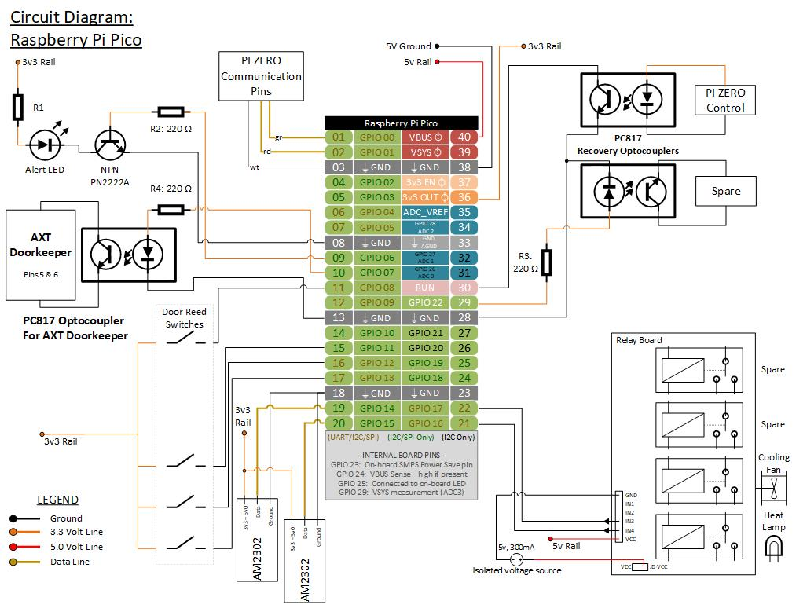

### Software Installation

The Raspberry Pi Pico software comes pre-installed on the Pi Pico itself. However, if you need to replace the software or the Pi Pico microcontroller, the following procedure can be used. This procedure can be followed by advanced users. Novice users may need to seek professional assistance.

#### 1) Download and Install MicroPython:

1. MicroPython 1.16 for the Raspberry Pi Pico may be downloaded from the following link: <https://micropython.org/resources/firmware/rp2-pico-20210618-v1.16.uf2>
2. While holding down the BOOTSEL button on the Raspberry Pi Pico, connect it to a desktop computer with a Micro-USB cable.
3. The Raspberry Pi Pico will appear as a storage device. Copy the uf2 file to the Raspberry Pi Pico.

#### 2) Connect the Raspberry Pi Pico

1. Connect the Raspberry Pi Pico to the Raspberry Pi Zero USB port using the 8” OTG cable. Ensure that the cable connector labelled ‘Host’ is plugged into the Pi Zero.

#### 3) Download Chicken Coop Monitor Software (if required)

Under normal circumstances, the Chicken Coop Monitor Software should already be downloaded to $HOME/ChickenCoopMonitor. If not, you may run the following commands to download the chicken coop software:

1. Log into the Raspberry Pi Zero
2. sudo apt install git -y
3. cd $HOME
4. git clone --recurse-submodules <https://github.com/infonick/ChickenCoopMonitor.git>

#### 4) Install the Chicken Coop Monitor Software on the Raspberry Pi Pico

|  |
| --- |
| IMPORTANT NOTES:   * The script will perform a system update on the Raspberry Pi Zero and install any required dependencies. This may take some time to complete. |

Run the following commands to install the chicken coop software on the Pi Pico.

1. cd $HOME/ChickenCoopMonitor/
2. chmod +x PicoSetupScript.bash
3. ./PicoSetupScript.bash
4. When the script is complete, the Raspberry Pi Pico will be reset and begin its operation. .

Please note that in order for the Raspberry Pi Pico to work, all components must be installed and connected. If the installation is not yet complete, the Raspberry Pi Pico may be disconnected until the entire system is ready.

## Relay Control Box

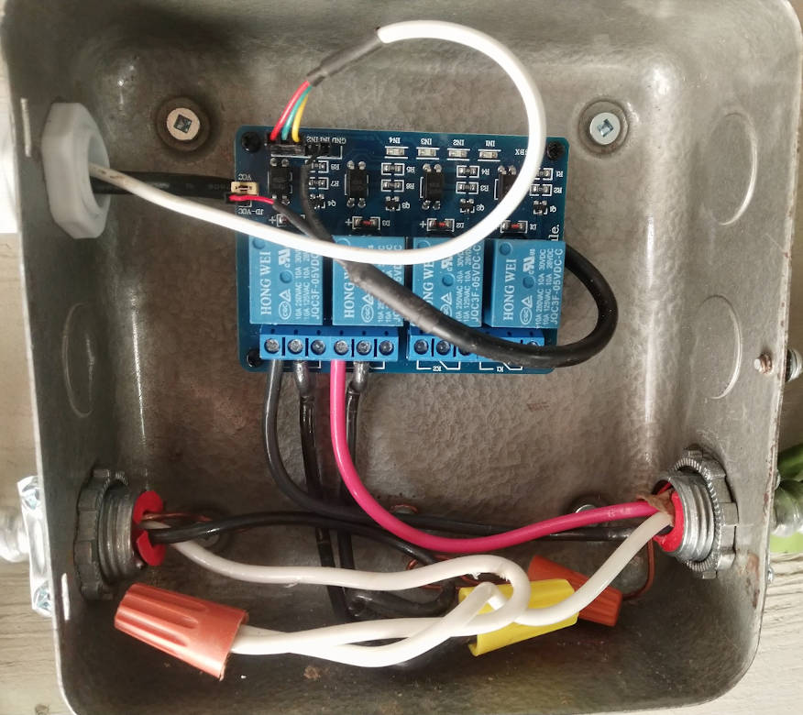

The relay control box contains the relays that control high-voltage devices such as a heat lamp or ventilation fan. Due to the risk of electrocution, it is recommended that the services of a qualified electrician or technician are sought for high voltage lines. All control boxes should be installed in a dry location.

1. Mount the control box.
2. Feed the USB power cable and the relay control wires into the box.
3. If there is a jumper between the ‘VCC’ and ‘JD-VCC’ pins, it can be disconnected.  
   **NOTE:** There are two pins labelled ‘VCC’. These pins are electrically equivalent and simply offer different connection locations.
4. The USB power cable is connected in the following way:
   * Red cable is connected to the pin labelled ‘JD-VCC’.
   * Black cable is connected to the pin labelled ‘GND’.
5. The 3-pin female end of the relay control cable is connected in the following way:
   * Red wire is connected to the pin labelled ‘VCC’.
   * Green wire is connected to the pin labelled ‘IN4’.
   * Yellow wire is connected to the pin labelled ‘IN3’.
6. Each relay is associated with 3 screw terminals. These are connected to the high-voltage wires in the following way:
   * The relay’s center terminal is connected to the live wire.
   * The relays left terminal is connected to the hot wire of the controlled device.
   * Terminal K4 controls the Heat Lamp.
   * Terminal K3 controls the Ventilation Fan.

This page intentionally left blank.

# User Manual

## Accessing the Login Screen

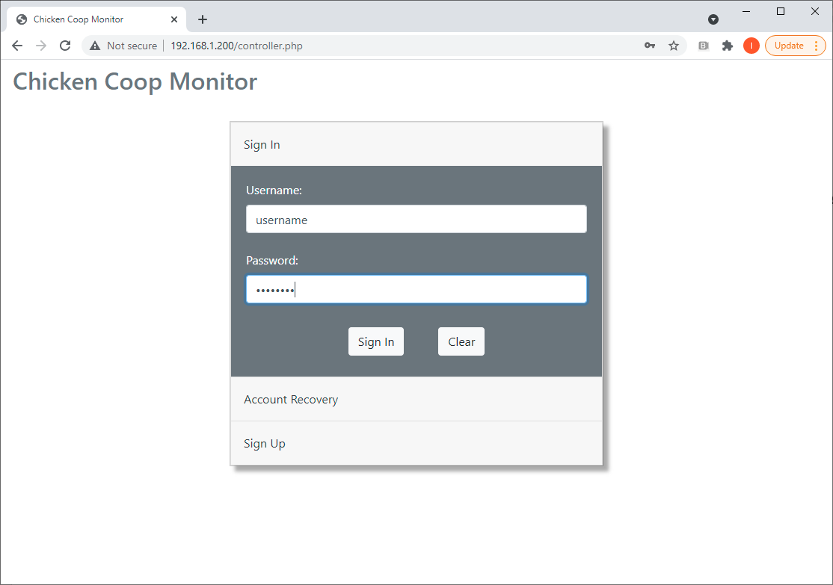

1. Open a web browser on a desktop computer, tablet, or smartphone.
2. In the address bar, enter the IP address of the Raspberry Pi Zero (you may wish to refer to your installation notes for the system IP address).
3. The system will present the Login Screen

## User Login

From the Login Screen:

1. Enter your username and password.
2. Click the ‘Sign In’ button.

If the username or password are invalid, a warning will be displayed and you will have the opportunity to try again.

## User Account Recovery

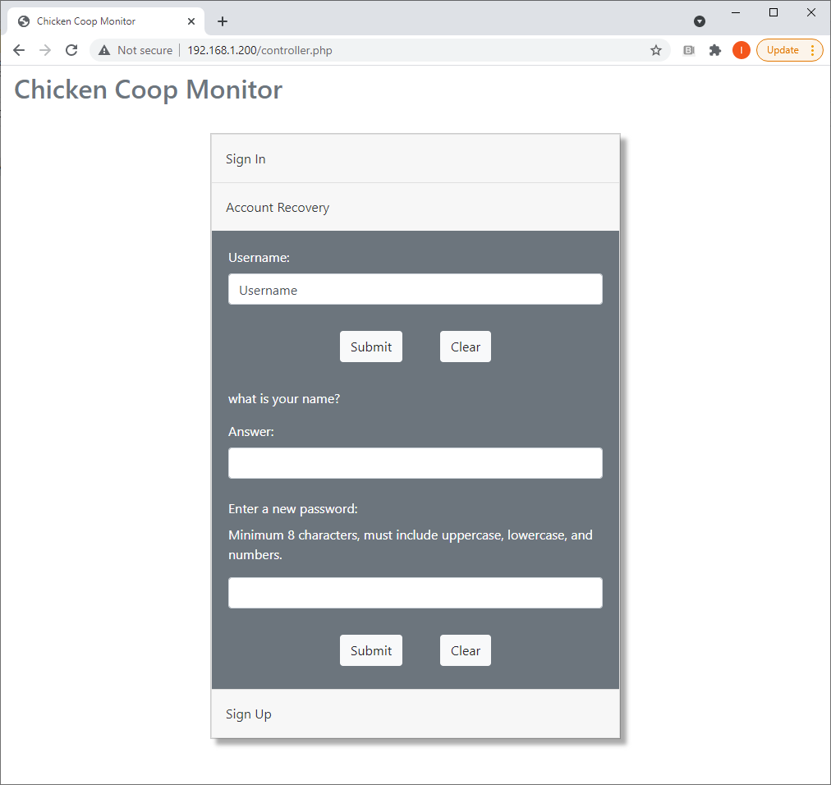

From the Login Screen:

1. Click on the ‘Account Recovery’ option.
2. Enter your Username and click ‘Submit’.
3. Your account recovery question will be presented. Provide the answer to the question in the text box provided.
4. Enter a new account password in the lowest text box and click ‘Submit’.

If the username, recovery question answer, or new password are invalid, a warning will be displayed and you will have the opportunity to try again.

## Register a New User Account

From the Login Screen:

1. Click on the ‘Sign Up’ option.
2. Complete all fields (username, password, first name, email address, recovery question, recovery question answer).
3. Click ‘Sign Up’.

If one or more of your entries is invalid, a warning will be displayed and you will have to try again.

## Signing Out

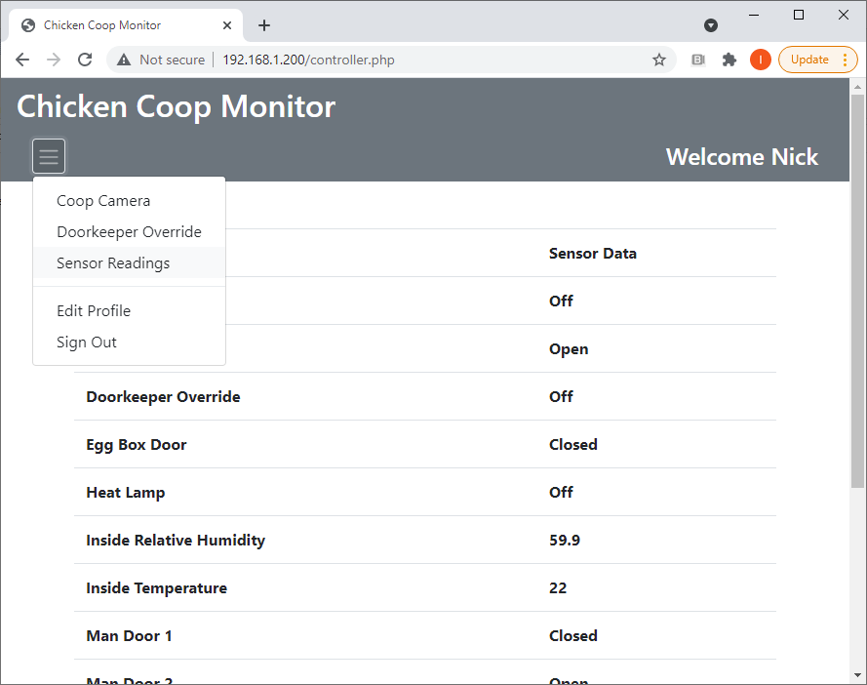

It is recommended that the user always sign out of the interface when finished. The ‘Sign Out’ function may be accessed from the dropdown menu:

1. Click the Menu Icon 
2. On the dropdown menu, click ‘Sign Out’.

Upon signing out of the interface, the user is returned to the Login Screen.

## Editing A User Profile

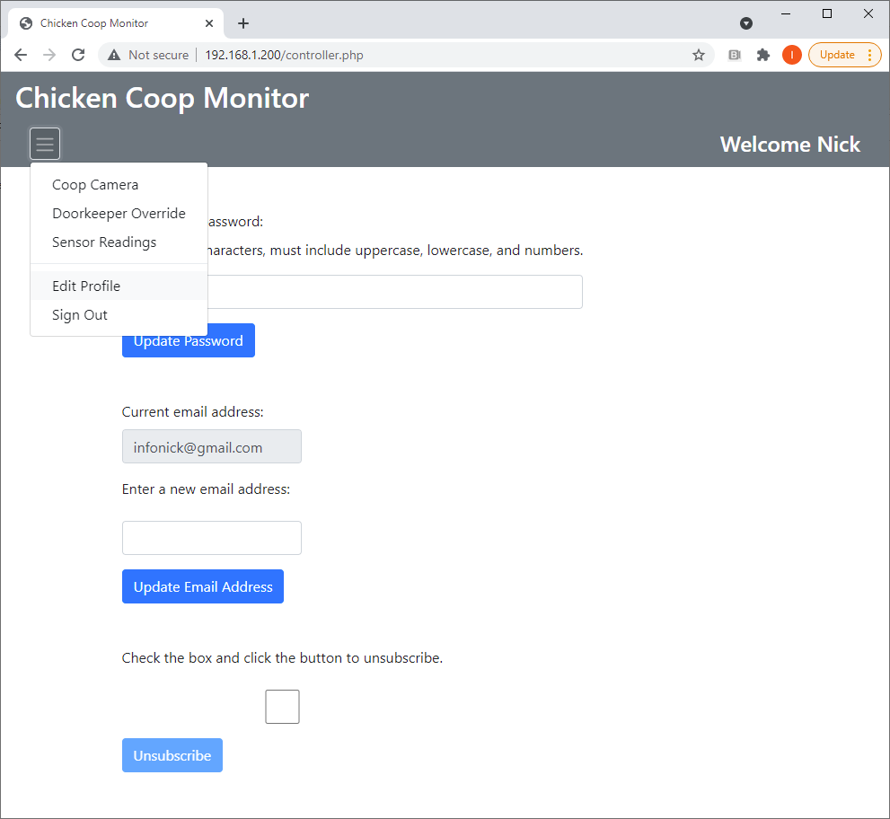

A user may edit their profile on the ‘Edit Profile’ page which may be accessed from the dropdown menu after logging in:

1. Click the Menu Icon 
2. On the dropdown menu, click ‘Edit Profile’.

On this page, the user may take three actions:

|  |  |
| --- | --- |
| **Update Password:** | A user may change their password.   1. Enter a new password in the first text box. 2. Click the ‘Update Password’ button.   If unsuccessful, a warning will be displayed and you will have a chance to try again. |
| **Update Email Address:** | The user may change their email address – the user’s current email address is displayed for convenience.   1. In the text box below the current email address, enter a new email address. 2. Click the ‘Update Email Address’ button.   If unsuccessful, a warning will be displayed and you will have a chance to try again. |
| **Unsubscribe:** | Unsubscribing permanently deletes the user’s account and all information associated with it. This action is not recoverable.   1. Click the square checkbox to confirm your intent to unsubscribe. 2. Click the ‘Unsubscribe’ button. |

## Accessing Sensor Data



1. After the user has logged in, the Sensor Readings page is the default view.
2. The Sensor Readings page may be accessed from the dropdown menu:
   1. Click the Menu Icon 
   2. On the dropdown menu, click ‘Sensor Readings’.
3. Alternatively, the Sensor Readings page may be accessed by clicking the words “Chicken Coop Monitor” in the top left hand corner of the page.

## Interpreting Sensor Data

Sensor data may be interpreted as follows:

|  |  |
| --- | --- |
| **Alert LED:** | May be ‘On’ or ‘Off’. Indicates if there are communication problems between the Raspberry Pi Zero and the Raspberry Pi Pico. |
| **Chicken Door:** | May be ‘Opening’, ‘Open’, ‘Closing’, or ‘Closed’. Indicates the status of the main chicken door. The ‘Open’ and ‘Closed’ states indicate that the door is fully open or closed. The ‘Opening’ and ‘Closing’ states indicate that the door is in between its fully open and closed position. The system can only sense whether the door is fully open or closed, so the ‘Opening’ and ‘Closing’ states are a best guess based on the information available. It is possible that the Doorkeeper could alter direction from opening to closing (or vice versa) without the system being able to detect the change. This should only occur under abnormal circumstances. |
| **Doorkeeper Override:** | May be ‘On’ or ‘Off’. If ‘On’, indicates that a user has commanded the system to open the chicken door and keep it open. A user must disable the command if the door is to resume automatic operation. If ‘Off’, the Doorkeeper will automatically open and close the chicken door. |
| **Egg Box Door:** | May be ‘Open’ or ‘Closed’. Indicates the current status of the egg box door. |
| **Heat Lamp:** | May be ‘On’ or ‘Off’. If ‘On’, indicates that the system has turned on the coop heat lamp. |
| **Inside Relative Humidity:** | Will be a percentage in the format of “00.0”. This percentage represents the relative humidity inside the coop. |
| **Inside Temperature:** | Will be a number in the format of “00.0”. This number represents the temperature in degrees Celsius inside the coop. |
| **Man Door 1:** | May be ‘Open’ or ‘Closed’. Indicates the current status of the coop man door. |
| **Man Door 2:** | May be ‘Open’ or ‘Closed’. If installed, indicates the current status of an additional man door. |
| **Man Door 3:** | May be ‘Open’ or ‘Closed’. If installed, indicates the current status of an additional man door. |
| **Outside Relative Humidity:** | Will be a percentage in the format of “00.0”. This percentage represents the relative humidity outside the coop. |
| **Outside Temperature:** | Will be a number in the format of “00.0”. This number represents the temperature in degrees Celsius outside the coop. |
| **Ventilation Fan:** | May be ‘On’ or ‘Off’. If ‘On’, indicates that the system has turned on the coop ventilation fan. |

## Accessing The Coop Camera and Camera LED

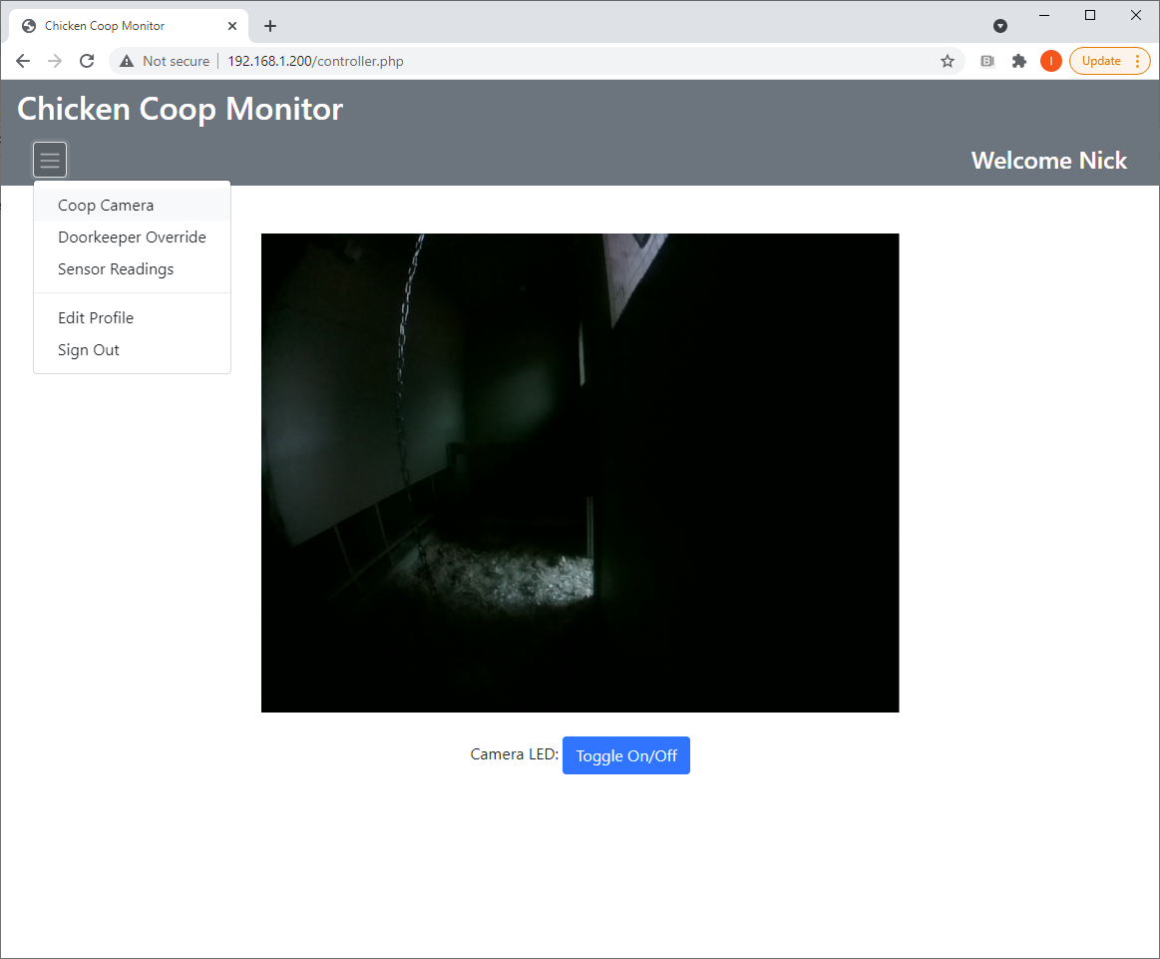

The Sensor Readings page may be accessed from the dropdown menu:

1. Click the Menu Icon 
2. On the dropdown menu, click ‘Coop Camera’.

The camera stream will be displayed. The camera LED may be toggled on and off by clicking the button labelled ‘Toggle On/Off’. As a precaution, the camera LED will only stay lit for a maximum of 30 seconds – after which a timer automatically turns the LED off so as not to disturb the chickens for too long if the network connection becomes disrupted. If the user wishes, the LED can then be toggled back on immediately after the 30 second timer has expired.

## Accessing the Doorkeeper Override

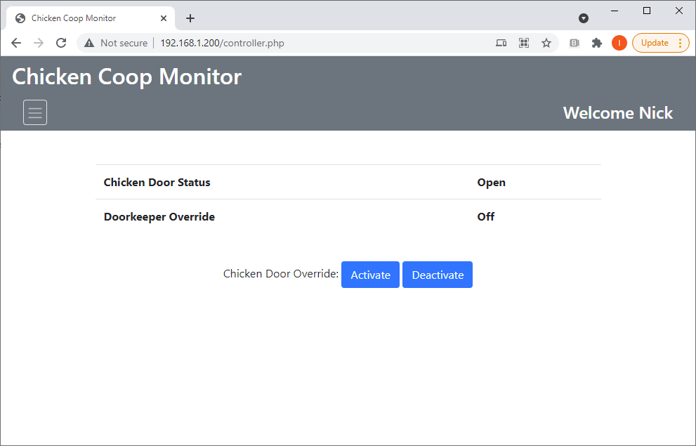

The Doorkeeper Override page may be accessed from the dropdown menu:

1. Click the Menu Icon 
2. On the dropdown menu, click ‘Doorkeeper Override’.

The Doorkeeper override may be used to command the system to manually open the chicken door, or keep the chicken door open and effectively disable the automatic operation of the doorkeeper. A user must disable this override if the Doorkeeper is to resume automatic operation. The status of both the chicken door and the Doorkeeper Override are displayed on this page for convenience. Refer to the Interpreting Sensor Data section for advice on how to interpret these status readings.

## Alert LED’s

Two red Alert LED’s are present on the coop exterior. If lit, these LED’s indicate communication problems between the Raspberry Pi Zero and the Raspberry Pi Pico. The user may try to unplug the power to clear the condition. If the condition is not resolved by cycling the power, it is not user serviceable and the assistance of a qualified technician should be sought.